Inventory Table:

1. Product type

2. SKU

3. Availability

4. Number of products sold

5. Customer demographics

6. Stock levels

7. Lead times

8. Order quantities

9. Lead time

10. Revenue generated

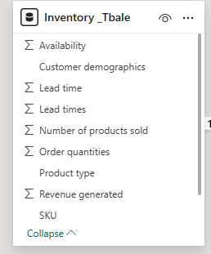

Manufacturing table

1. Product type

2. SKU

3. Production volumes

4. Manutacturing lead time

5. Manufacturing costs

6. Inspection results

7. ⁠ defect rates

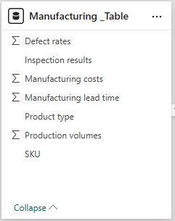

Supplier Table

1. Supplier name

2. Location

3. Lead time

4. transportation modes

5. Routue

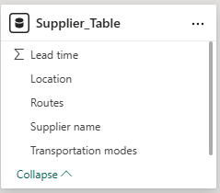

Supply chain table

1. Product type

2. SKU

3. Price

4. Availability

5. Number of products sold

6. Revenue generated

7. Customer demographics

8. Stock levels

9. Lead times

10. Order quantities

11. Shipping times

12. Shipping carriers

13. Shipping costs

14. Supplier name

15. Location

16. Lead time

17. Transportation modes

18. Routes

